Annex I (a): Co-financing letters and other agreements.

A. Co-financing letter from Ministry of Agriculture and Rural Areas


October 22, 2018
Adriana Dinu
GEF Executive Coordinator
United Nations Development Programme
One United Nations Plaza
New York, NY 10017, USA
Subject: Co-financing Commitment Letter for the UNDP supported, GEF financed project
"Strengthening coordinated approaches to reduce invasive alien species (IAS) threats to globally significant agrobiodiversity and agroecosystems in China"
Dear Ms. Dinu,
This letter confirms our co-financing commitment for the UNDP supported, GEF financed project "Strengthening coordinated approaches to reduce invasive alien species (IAS) threats to globally significant agrobiodiversity and agroecosystems in China", child project No. 2 under the PRC-GEF Partnership Program on Sustainable Agricultural Development.
We confirm USD 2.12 million (CNY 14.62 million, at an exchange rate Of 6.9) Of co-financing to ensure successful implementation of the project, through completion of complementary initiatives, active participation of our staff and provision of support services. Complementary initiatives.
We 100k forward to the commencement of the project.
Sincerely,
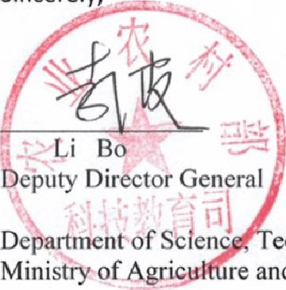
echnology and Education re and Rural Affairs
B. Co-financing letter Chinese Academy of Inspection and Quarantine.
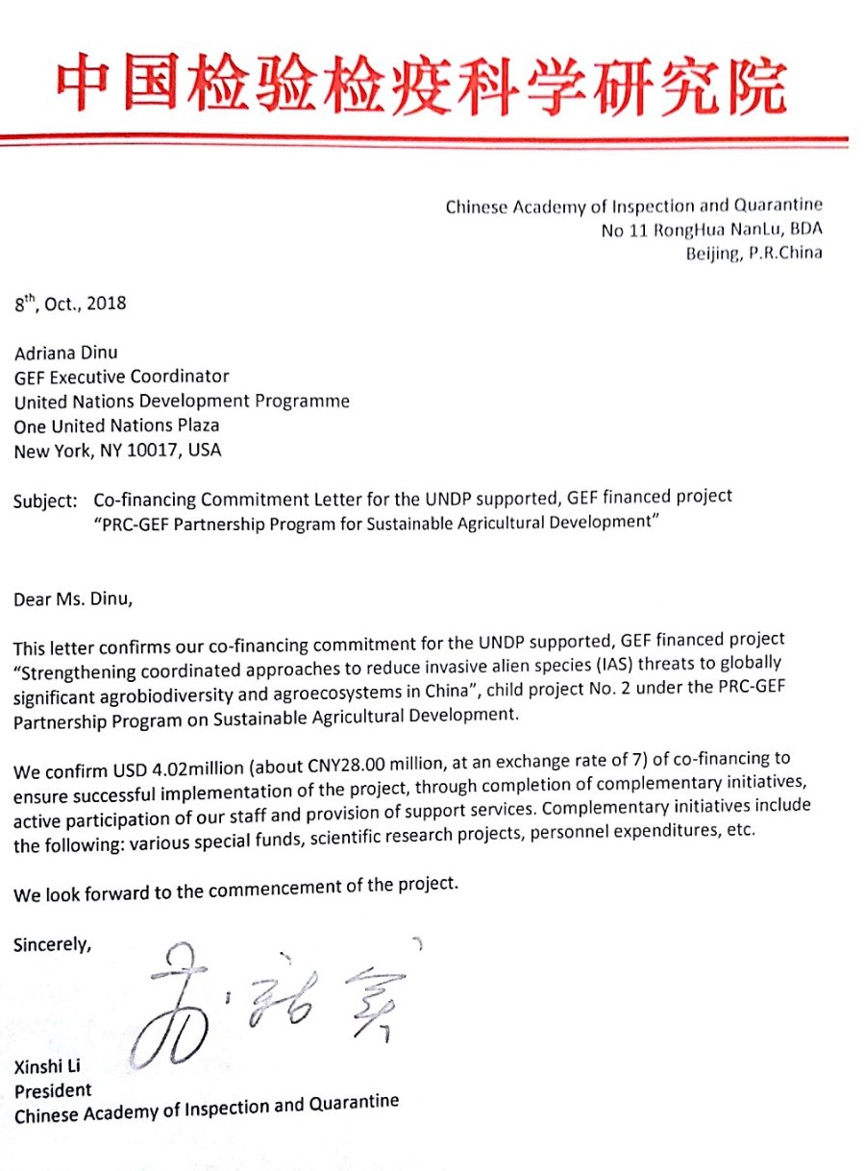

C. Co-financing letter from Ministry of Ecology and Environment.
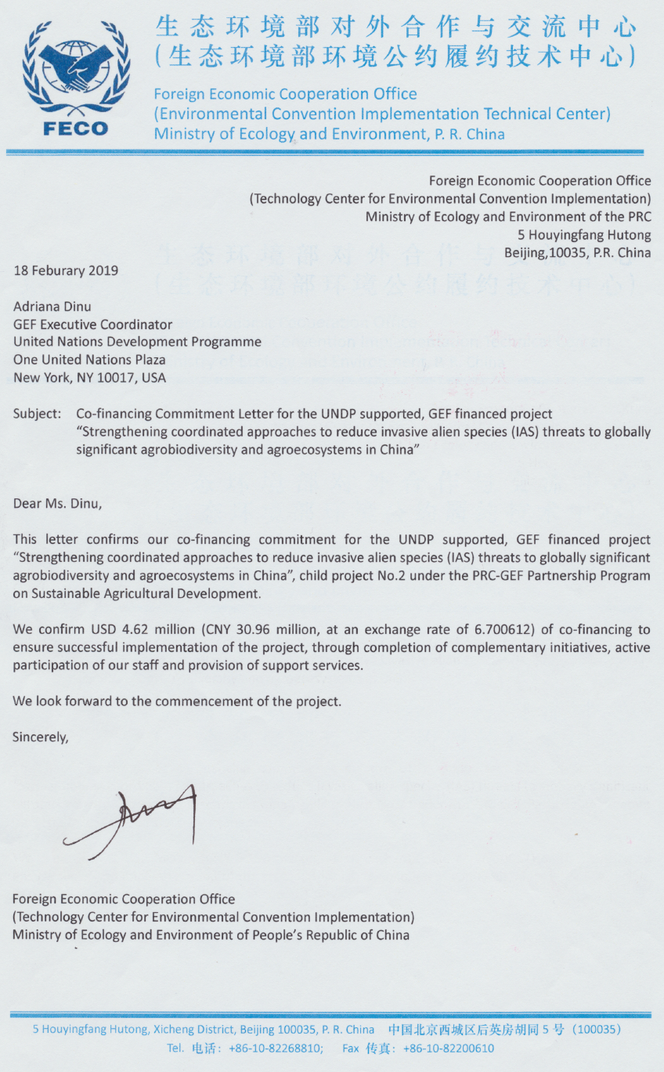
D. Co-financing letter (translation) from Chongqing Agriculture Department.

16, October, 2018

Adriana Dinu
GEF Executive Coordinator
United Nations Development Programme
One United Nations Plaza
New York, NY 10017, USA

Subject: Co-financing Commitment Letter for the UNDP supported, GEF financed project
“Strengthening Coordinated Approaches to Reduce Invasive Alien Species (IAS) Threats to Globally Significant Agrobiodiversity and Agroecosystems in China”

Dear Ms. Dinu,

This letter confirms our co-financing commitment for the UNDP supported, GEF financed project “Strengthening Coordinated Approaches to Reduce Invasive Alien Species (IAS) Threats to Globally Significant Agrobiodiversity and Agroecosystems in China”, child project No. 2 under the PRC-GEF Partnership Program on Sustainable Agricultural Development.

We confirm USD 3.15 million (CNY 21.7023 million, at an exchange rate of 6.8899) of co-financing to ensure successful implementation of the project, through completion of complementary initiatives, active participation of our staff and provision of support services.

We look forward to the commencement of the project.

Sincerely,

Mr.Peng Luyou
Deputy Director

E. Co-financing letter (translation) from Hainan Agriculture Department.
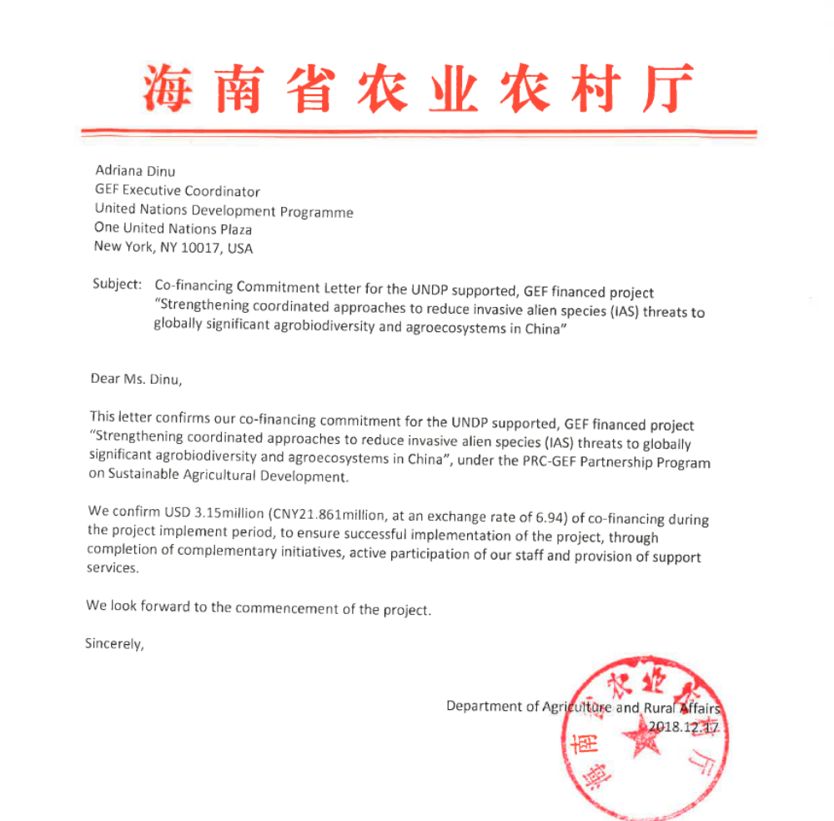

F. Co-financing letter (translation) from Chongqing Late Orange Planting Farmers’ Cooperative.

16, October, 2018

Adriana Dinu
GEF Executive Coordinator
United Nations Development Programme
One United Nations Plaza
New York, NY 10017, USA

Subject: Co-financing Commitment Letter for the UNDP supported, GEF financed project
“Strengthening Coordinated Approaches to Reduce Invasive Alien Species (IAS) Threats to Globally Significant Agrobiodiversity and Agroecosystems in China”

Dear Ms. Dinu,

This letter confirms our co-financing commitment for the UNDP supported, GEF financed project “Strengthening Coordinated Approaches to Reduce Invasive Alien Species (IAS) Threats to Globally Significant Agrobiodiversity and Agroecosystems in China”, child project No. 2 under the PRC-GEF Partnership Program on Sustainable Agricultural Development.

Our company is committed to agricultural production development. We expect that our cumulative investments over the next five years 2019-2024 will be approximately CNY 4.34 million (USD 0.63 million), focused on agricultural development in the county. We confirm that these investments can be considered as co-financing for the proposed UNDP supported, GEF financed project. We are very interested in working together with the UNDP-GEF project in strengthening coordinated approaches to reduce invasive alien species (IAS) threats to globally significant agrobiodiversity and agroecosystems in China.

We look forward to the commencement of the project.

Sincerely,

Mr.Cao Tingxiao
President

G. Co-financing letter (translation) from Wenchang Wenting Agritourism and Ecological Agriculture Co. Ltd.

1, December, 2018

Adriana Dinu
GEF Executive Coordinator
United Nations Development Programme
One United Nations Plaza
New York, NY 10017, USA

Subject: Co-financing Commitment Letter for the UNDP supported, GEF financed project
“Strengthening Coordinated Approaches to Reduce Invasive Alien Species (IAS) Threats to Globally Significant Agrobiodiversity and Agroecosystems in China”

Dear Ms. Dinu,

This letter confirms our co-financing commitment for the UNDP supported, GEF financed project “Strengthening Coordinated Approaches to Reduce Invasive Alien Species (IAS) Threats to Globally Significant Agrobiodiversity and Agroecosystems in China”, child project No. 2 under the PRC-GEF Partnership Program on Sustainable Agricultural Development.

Our company is committed to agricultural production development. We expect that our cumulative investments over the next five years 2019-2024 will be approximately CNY 4.3405 million (USD 0.63 million), focused on agricultural development in the county. We confirm that these investments can be considered as co-financing for the proposed UNDP supported, GEF financed project. We are very interested in working together with the UNDP-GEF project in strengthening coordinated approaches to reduce invasive alien species (IAS) threats to globally significant agrobiodiversity and agroecosystems in China.

We look forward to the commencement of the project.

Sincerely,

Xing Jin
General Manager

H. Co-financing letter (translation) from Beijing Huaheng Rongtong Technology Co. Ltd.
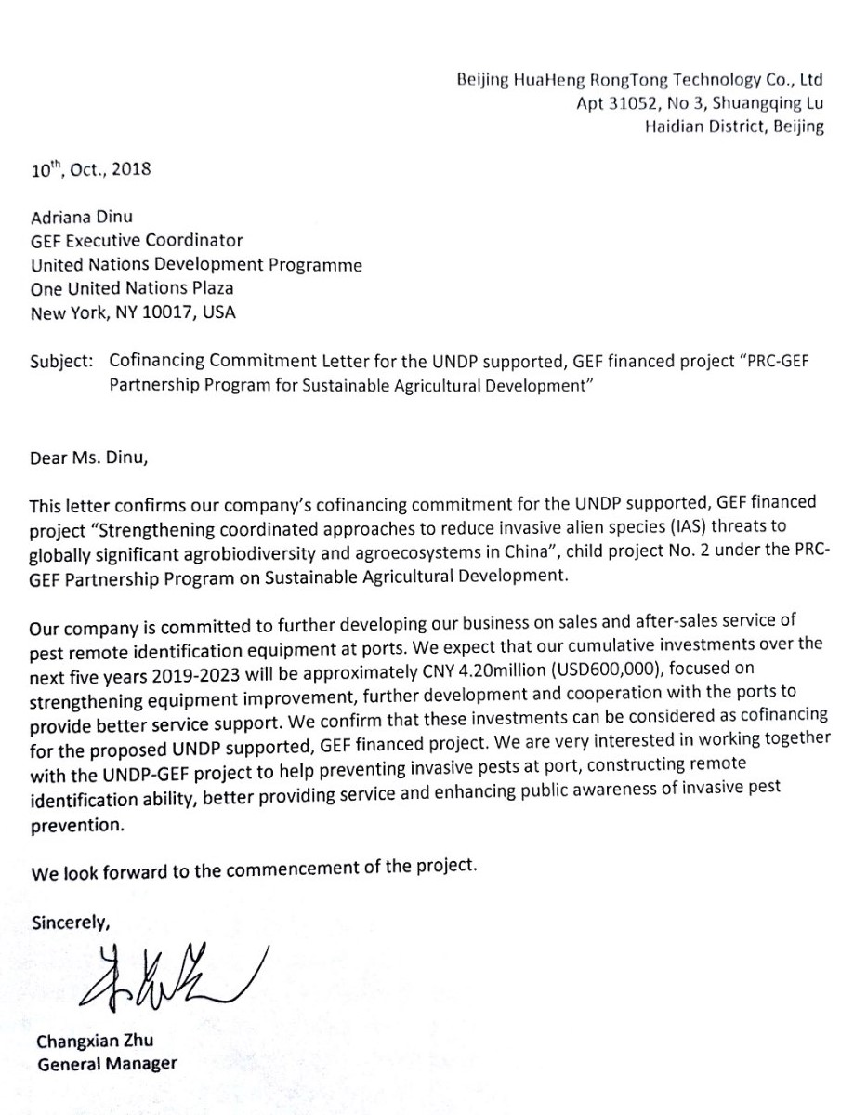

Annex I (b): Letters of Agreements.

I. Letter of agreement between UNDP and Chinese Academy of Inspection and Quarantine Research, General Administration of Customs in China (GACC/CAIQ)

Annex N (B) LETTER OF AGREEMENT
BETWEEN

THE UNITED NATIONS DEVELOPMENT PROGRAMME AND THE CHINESE ACADEMY OF INSPECTION AND QURANTINE RESEARCH, GENERAL ADMINISTRATION OF CUCTOMS, CHINA, TO CARRY OUT ACTIVITIES WHEN UNDP PROVIDES SUPPORT SERVICES TO

The GEF-Government of China-UNDP Strengthening coordinated approaches to reduce invasive alien species (IAS) threats to globally significant agrobiodiversity and agroecosystems in China project

Dear Sir/Madame,

1. Reference is made to the consultations between officials of the United Nations Development Programme (hereinafter referred to as “UNDP”) in China and officials of the Chinese Academy of Inspection and Quarantine Research, General Administration of Customs in China (GACC/CAIQ) with respect to the realization of activities by GACC/CAIQ in the implementation of the UNDP support services to the project Strengthening coordinated approaches to reduce invasive alien species (IAS) threats to globally significant agrobiodiversity and agroecosystems in China PIMS2158, as specified in Attachment 1: Project Document, to which UNDP has been selected as a responsible party.

2. In accordance with the LOA signed between the government implementing partner and UNDP for support services and with the following terms and conditions, we confirm our acceptance of the activities to be provided by GACC/CAIQ towards the project, as specified in Attachment 2: Description of Activities (hereinafter referred to as “Activities”). Close consultations will be held between GACC/CAIQ and UNDP on all aspects of the Activities.

3. GACC/CAIQ shall be fully responsible for carrying out, with due diligence and efficiency, all Activities in accordance with its financial regulations, rules and other directives, only to the extent they are consistent with UNDP’s Financial Regulations and Rules. In all other cases, UNDP's Financial Regulations and Rules must be followed.

4. In carrying out the activities under this Letter, the personnel and sub-contractors of GACC/CAIQ shall not be considered in any respect as being the employees or agents of UNDP. UNDP does not accept any liability for claims arising out of acts or omission of GACC/CAIQ or its personnel, or of its contractors or their personnel, in performing the Activities or any claims for death, bodily injury, disability, damage to property or other hazards that may be suffered by GACC/CAIQ, and its personnel as a result of their work pertaining to the Activities.

5. Any subcontractors, including NGOs under contract with GACC/CAIQ, shall work under the supervision of the designated official of GACC/CAIQ. These subcontractors shall remain accountable to GACC/CAIQ for the manner in which assigned functions are discharged.

6 Upon signature of this Letter, UNDP will make payments to GACC/CAIQ, according to the schedule of payments specified in Attachment 3: Schedule of Activities, Facilities and Payments.

7. GACC/CAIQ shall not make any financial commitments or incur any expenses which would exceed the budget for the Activities as set forth in Attachment 3. GACC/CAIQ shall regularly consult with UNDP concerning the status and use of funds and shall promptly advise UNDP any time when GACC/CAIQ is aware that the budget to carry out these Activities is insufficient to fully implement the project in the manner set out in the Attachment 2. UNDP shall have no obligation to provide GACC/CAIQ with any funds or to make any reimbursement for expenses incurred by GACC/CAIQ in excess of the total budget as set forth in Attachment 3.

8. GACC/CAIQ shall submit a cumulative financial report each quarter (31 March, 30 June, 30 September and 31 December). The report will be submitted to UNDP through the UNDP Country Director or UNDP Resident Representative within 30 days following those dates. The format will follow the standard UNDP expenditure report [a model copy of which is provided as Attachment 4]. UNDP will include the financial report by GACC/CAIQ in the financial report for the Strengthening coordinated approaches to reduce invasive alien species (IAS) threats to globally significant agrobiodiversity and agroecosystems in China PIMS2158.

9. GACC/CAIQ shall submit such progress reports relating to the Activities as may reasonably be required by the project manager in the exercise of his or her duties.

10. GACC/CAIQ shall furnish a final report within 6 months after the completion or termination of the Activities, including a list of non-expendable equipment purchased by GACC/CAIQ and all relevant audited or certified financial statements and records related to such Activities, as appropriate, pursuant to its Financial Regulations and Rules.

11. Equipment and supplies that may be furnished by UNDP or procured through UNDP funds will be disposed as agreed, in writing, between UNDP and GACC/CAIQ.

12. Any changes to the LOA between the government implementing partner and UNDP for support services which would affect the work being performed by GACC/CAIQ in accordance with Attachment 2 shall be recommended only after consultation between the parties.

13. For any matters not specifically covered by this Letter, the Parties would ensure that those matters shall be resolved in accordance with the appropriate provisions of the LOA for support services and any revisions thereof and in accordance with the respective provisions of the Financial Regulations and Rules of the GACC/CAIQ and UNDP.

14. The arrangements described in this Letter will remain in effect until the end of the project, or the completion of Activities according to Attachment 2, or until terminated in writing (with 30 days notice) by either party. The schedule of payments specified in Attachment 3 remains in effect based on continued performance by GACC/CAIQ unless it receives written indication to the contrary from UNDP.

15. Any balance of funds that is undispersed and uncommitted after the conclusion of the Activities shall be returned within 90 days to UNDP.

16. Any amendment to this Letter shall be effected by mutual agreement, in writing,

17. All further correspondence regarding this Letter, other than signed letters of agreement or amendments thereto should be addressed to Agi Veres, UNDP Resident Representative, UNDP China Country Office Liangmahe Nanlu 2 100001 Beijing
.

18. GACC/CAIQ shall keep the UNDP Country Director/Resident Representative fully informed of all actions undertaken by them in carrying out this Letter.

19. UNDP may suspend this Agreement, in whole or in part, upon written notice, should circumstances arise which jeopardize successful completion of the Activities.

20. Any dispute between the UNDP and GACC/CAIQ arising out of or relating to this Letter which is not settled by negotiation or other agreed mode of settlement, shall, at the request of either party, be submitted to a Tribunal of three arbitrators. Each party shall appoint one arbitrator, and the two arbitrators so appointed shall appoint a third arbitrator, who shall be the chairperson of the Tribunal. If, within 15 days of the appointment of two arbitrators, the third arbitrator has not been appointed, either party may request the President of the International Court of Justice to appoint the arbitrator referred to. The Tribunal shall determine its own procedures, provided that any two arbitrators shall constitute a quorum for all purposes, and all decisions shall require the agreement of any two arbitrators. The expenses of the Tribunal shall be borne by the parties as assessed by the Tribunal. The arbitral award shall contain a statement of the reasons on which it is based and shall be final and binding on the parties.

21. If you are in agreement with the provisions set forth above, please sign and return to this office two copies of this Letter. Your acceptance shall thereby constitute the basis for your GACC/CAIQ participation in the implementation of the project.

Yours sincerely,
Signed on behalf of UNDP

[Name and title]
[Date]

Signed on behalf of [the Government ministry/institution/IGO]]
[Name and title]
[Date]

Attachment 1

PROJECT DOCUMENT

Attachment 2

DESCRIPTION OF ACTIVITIES

Project number: PIMS 2158
Project title: Strengthening coordinated approaches to reduce invasive alien species (IAS) threats to globally significant agrobiodiversity and agroecosystems in China

GACC/CAIQ will be responsible for the implementation of the project activities outlined in the project document and in accordance to the guidance provided in said document. Below is a summary listing of the activities in which GACC/CAIQ will be involved in. In this connection, GACC/CAIQ will either provide support to a MARA lead and coordinated activity or will be taking on the lead role (which include the activity coordination’s between the project partners. Where GACC/CAIQ has the activity lead the activity has the notation (GACC-Lead), and where GACC/CAIQ has a supporting role the activity has the notation (GACC-Support).

Furthermore, where the notation (GACC-Lead) or (GACC-Support) are written in Bold, it signifies that GACC/CAIQ will be utilizing GEF funding for the implementation of the activity.

OUTCOME 1: Strengthened policy, regulatory and strategic framework for IAS Management incorporated into inter-sectoral response mechanisms for the reduction of IAS threats to agrobiodiversity, including traditional varieties and GRFA.
Output 1.1 Inter-agency coordination mechanisms are established to support IAS strategic plan implementation and improve the management of IAS threats to agrobiodiversity.
1.1.1 Establish and operationalize the National IAS Coordination Group (GACC-Support)

1.1.2. Create and run Provincial IAS Management Coordinating Groups in Hainan and Chongqing (GACC-Support.)
1.1.3. Create and run County IAS Management Coordinating Groups in Wenchang and Bishan (GACC-Support.)
1.1.4. Hold annual multi-sector coordination seminars (GACC-Support.)

Output 1.2 Regulatory framework to strengthened management of IAS and their negative impacts on agrobiodiversity are reviewed and revised/ developed at the national level and in target provinces to provide protection of agrobiodiversity.
1.2.1. Revise and adopt the national regulation framework to optimize cross-sectoral IAS Management (GACC-Support.)
1.2.2. Develop provincial regulation for IAS prevention, control and management in Hainan and Chongqing (GACC-Support.)
1.2.3. Revise IAS Early Warning Guidelines (GACC-Support.)
1.2.4. Revise IAS rapid response guidelines (GACC-Support.)
1.2.5. Develop an IAS Biodiversity Risk Assessment Guideline (GACC-Support.)
1.2.6 Develop IAS buffer zone guideline for areas surrounding ecological functioning zones and protected areas (GACC-Support.)
1.2.9 Include biodiversity in the updating of the 2007 National Quarantine Pest list (GACC-Lead.)

Output 1.3 Strategic plans for IAS are developed at national and provincial level defining common targets and actions, and clarifying the responsibilities of agencies involved in IAS management, including roles related to agrobiodiversity conservation.
1.3.1 Develop the strategic vision and content of the National IAS Management Strategy and Action Plan (IAS NSAP 2021-2030) (GACC-Support.)
1.3.2. Prepare the National IAS Management strategy and action plan (IAS NSAP 2021-2030) (GACC-Support.)
1.3.3. Prepare Provincial IAS Management Strategy and Action Plan (IAS PSAP 2022-2030) for Hainan and Chongqing (GACC-Support.)

Output 1.4 Sectoral plans are revised to align with the national IAS strategic plan and updated regulations, mainstreaming relevant actions, indicators and targets to address IAS threats to agroecosystems.
1.4.1c Develop GACC Implementation Plans for the IAS NSAP 2021-2030 (GACC-Lead)
1.4.2c Develop provincial customs Implementation Plans for the IAS NSAP 2021-2030 (GACC-Lead)
1.4.3. Ministry/administration approval of individual ministry/administrations and provincial/department IAS Implementation Plans (GACC-Lead).

Outcome 2: Strengthened institutional capacities and interagency response mechanisms for IAS detection, quarantine disposal, monitoring, early warning and rapid response.
Output 2.1 Methodologies for risk assessment, early warning and rapid response to IAS incursions in agroecosystems are developed and used.
2.1.3. Develop provincial IAS Early Warning Methodologies in Hainan (GACC-Support)
2.1.4. Operationalize IAS Early Warning in Hainan (GACC-Support)

Output 2.2 Strengthened IAS inspection, detection, quarantine and disposal systems are developed for ports, and demonstrated at Yangpu port, reducing the threat of entry of IAS through a high-risk invasion pathway.
2.2.1. Update the national technical specification for IAS inspection, quarantine and disposal used at Yangpu port (GACC-Lead)
2.2.2. Review and update inspection standards/methodologies (GACC-Lead)
2.2.3 Formulate/revise quarantine management system/methodologies (GACC-Lead)
2.2.4. Develop and organize trainings. (GACC-Lead)

Output 2.3 Skills base of core IAS management agencies is strengthened through training and the integration of R&D supporting upscaling of IAS prevention, control and management systems.
2.3.3. Develop an IAS application (APP) (GACC-Support)

Outcome 4: Sustainability and impact of project/program results enhanced by effective KM, awareness, M&E and coordination.
Output 4.1 Awareness-raising materials and educational curricula are developed and used at national, provincial and local level.
4.1.1. Undertake the knowledge, attitude and practices (KAP) survey (GACC-Support)
4.1.3c. Prepare GACC IAS education and awareness-raising materials (GACC-Lead)
4.1.4c Develop and publicize GACC related Massive Open Online Courses (MOOC) (GACC-Lead).
4.1.5c. Organize publicity and awareness events at national, provincial and local levels (GACC-Lead)
4.1.6. Organize a full day IAS side event in connection with the Fifteenth Meeting of the Conference of the Parties to the Convention on Biological Diversity (COP15) (GACC-Support)
4.1.7 GACC best practice learning and knowledge sharing exchange missions (GACC-Lead)

Output 4.2 A national web-based IAS information and communication platform is established providing a forum for information-sharing and communication on prevention, control and management of IAS in agroecosystems.
4.2.1. Design the IAS Knowledge Management platform (GACC-Support)
4.2.2. House and populate the IAS Knowledge Management Platform (GACC-Support)
4.2.3 Popularize the IAS Knowledge Management platform (GACC-Support)

Output 4.3 Strengthened engagement in international cooperation on the prevention, control and management of IAS impacts on agrobiodiversity.
4.3.1. Support China’s advocating IAS Management (with Hainan as the main example) in international settings and meetings (GACC-Support)
4.3.2. Support China’s bilateral IAS partnership agreements on IAS Management activities and training programs (GACC-Support)

Output 4.4 A Program Coordination, Monitoring and Evaluation Plan is developed, adopted and effectively implemented.
4.4.2. Hold project inception workshops, within 3 month of project document signing (GACC-Support)
4.4.3. Prepare C-SAP Program annual reports and other relevant project/program reporting (GACC-Support)
4.4.4. Prepare C-SAP 2 IAS project annual reports, PIR and other relevant project/program reporting (GACC-Support)
4.4.5. Procure and support an independent midterm review of the project and program (GACC-Support)
4.4.6. Procure and support an independent terminal evaluation of the project and program (GACC-Support)
4.4.8. Hold C-SAP 2 IAS project Steering Committee meetings annually (GACC-Support)

C-SAP 2 PIMS5821 Multi Year Work Plan (Role of GACC)

Project: Strengthening coordinated approaches to reduce invasive alien species (IAS) threats to globally significant agrobiodiversity and agroecosystems in China

Task | Responsible Party | Year 1 |  |  |  | Year 2 |  |  |  |  |  |  |  | Year 3 |  |  |  |  |  |  |  | Year 4 |  |  |  |  |  |  |  | Year 5
Task | Responsible Party | Q1 | Q2 | Q3 | Q4 | Q1 |  | Q2 |  | Q3 |  | Q4 |  | Q1 |  | Q2 |  | Q3 |  | Q4 |  | Q1 |  | Q2 |  | Q3 |  | Q4 |  | Q1 |  | Q2 |  | Q3 | Q4
Component 1 |  | Strengthen the enabling environment.
Output 1.1 |  | Inter-agency coordination mechanisms are established to support IAS strategic plan implementation and improve the management of IAS threats to agrobiodiversity.
1.1.1 | GACC-Support MARA led activity
1.1.2 | GACC-Support MARA led activity
1.1.3 | GACC-Support MARA led activity
1.1.4 | GACC-Support MARA led activity
Output 1.2 |  | Regulatory framework to strengthened management of IAS and their negative impacts on agrobiodiversity are reviewed and revised/ developed at the national level and in target provinces to provide protection of agrobiodiversity
1.2.1 | GACC-Lead
1.2.2 | GACC-Lead
1.2.3 | GACC-Support MARA led activity
1.2.4 | GACC-Support MARA led activity
1.2.5 | GACC-Support MARA led activity
1.2.6 | GACC-Support MARA led activity
1.2.9 | GACC-Lead
Output 1.3 |  | Strategic plans for IAS are developed at national and provincial level defining common targets and actions, and clarifying the responsibilities of agencies involved in IAS management, including roles related to agrobiodiversity conservation.
1.3.1 | GACC-Support MARA led activity
1.3.2 | GACC-Support MARA led activity
1.3.3 | GACC-Support MARA led activity
Output 1.4 |  | Sectoral strategies are revised to align with the national IAS strategic plan, mainstreaming relevant actions, indicators and targets to address IAS threats to agroecosystems.
1.4.1 | GACC-Lead
1.4.2 | GACC-Lead
1.4.3 | GACC-Lead
Component 2 |  | Strengthened IAS Management frameworks and institutional capacity.
Output 2.1 |  | Methodologies for risk assessment, early warning and rapid response to IAS incursions in agroecosystems are developed and used.
2.1.3 | GACC-Support MARA led activity
2.1.4 | GACC-Support MARA led activity
Output 2.2 |  | Strengthened IAS inspection, detection, quarantine and disposal systems are developed for ports, and demonstrated at Yangpu port, reducing the threat of entry of IAS through a high-risk invasion pathway.
2.2.1 | GACC-Lead
2.2.2 | GACC-Lead
2.2.3 | GACC-Lead
2.2.4 | GACC-Lead
Output 2.3 |  | Skills base of core IAS management agencies is strengthened through training and the integration of R&D supporting upscaling of IAS prevention, control and management systems.
2.3.3 | GACC-Support MARA led activity
Component 3 |  | Demonstration of IAS threat reduction in agroecosystems.
Output 3.1 |  | Farming communities, including cooperatives, agricultural enterprises and other relevant stakeholders are capacitated through training building the knowledge and skills base of all groups to work together to address IAS threats to agroecosystems.
Output 3.2 |  | Participatory approaches for preventing, controlling and managing IAS are demonstrated in 60 ha within two target agricultural landscapes, providing viable and cost-effective techniques to reduce IAS threats and impacts.
Output 3.3 |  | Improved understanding of IAS distribution and impacts on agrobiodiversity, at two agriculture landscapes through targeted and management-oriented surveys and assessments.
Output 3.4 |  | Operational IAS management plans are developed for two target agricultural landscapes and implemented on 35,000 ha demonstrably reducing IAS threats on agrobiodiversity and traditional varieties.
Component 4 |  | Awareness raising, knowledge management and coordination.
Output 4.1 |  | Awareness-raising materials and educational curricula are developed and used at national, provincial and local level.
4.1.1 | GACC-Support MARA led activity
4.1.3 | GACC-Lead
4.1.4 | GACC-Lead
4.1.5 | GACC-Lead
4.1.6 | GACC-Support MARA led activity
4.1.7 | GACC-Lead
Output 4.2 |  | national web-based IAS information and communication platform is established providing a forum for information-sharing and communication on prevention, control and management of IAS in agroecosystems.
4.2.1 | GACC-Support MARA led activity
4.2.2 | GACC-Support MARA led activity
4.2.3 | GACC-Support MARA led activity
Output 4.3 |  | Strengthened engagement in international cooperation on the prevention, control and management of IAS impacts on agrobiodiversity.
4.3.1 | GACC-Support MARA led activity
4.3.2 | GACC-Support MARA led activity
Output 4.4 |  | Program Coordination, Monitoring and Evaluation Plan is developed, adopted and effectively implemented.
4.4.3 | GACC-Support MARA led activity
4.4.4 | GACC-Support MARA led activity
4.4.5 | GACC-Support MARA led activity
4.4.6 | GACC-Support MARA led activity
4.4.8 | GACC-Support MARA led activity

Attachment 3

Scheduled of Activities, Facilities and Payments

Year ____________

EXPECTED CP OUTPUTS  and indicators including annual targets | PLANNED ACTIVITIES  List all activities to be undertaken during the year towards stated outputs | Timeframe |  |  |  | Planned Budget |  | Schedule of payments by UNDP
EXPECTED CP OUTPUTS  and indicators including annual targets |  | Q1 | Q2 | Q3 | Q4 | Budget Description | Amount | Q1 | Q2 | Q3 | Q4
 |  |  |  |  |  | Total

Note:

- Expenditures for personnel services may be limited to salary, allowances and other entitlements, including the reimbursement of income taxes due and travel costs on appointment to the project, duty travel within the programme country or region and repatriation costs.
- Adjustments within each of the sections may be made in consultation between UNDP and [the Government ministry/institution/IGO]]. Such adjustments may be made if they are in keeping with the provisions of the Programme Support/Project Document and if they are found to be in the best interest of the project.
Attachment 4

MODEL UNDP EXPENDITURE REPORT
Period _______

EXPECTED CP OUTPUTS  and indicators including annual targets | PLANNED ACTIVITIES  List all activities to be undertaken during the year towards stated outputs | Planned Budget |  | Payments and Expenditures
EXPECTED CP OUTPUTS  and indicators including annual targets |  | Budget Description | Amount | Payments received | Expenditures | Balance
 |  | Total

J. Letter of agreement between UNDP and Foreign Economic Cooperation Office, Ministry of Ecology and Environment (MEE/FECO)

Annex I LETTER OF AGREEMENT
BETWEEN

THE UNITED NATIONS DEVELOPMENT PROGRAMME AND THE CHINESE ACADEMY OF INSPECTION AND QURANTINE RESEARCH, GENERAL ADMINISTRATION OF CUCTOMS, CHINA, TO CARRY OUT ACTIVITIES WHEN UNDP PROVIDES SUPPORT SERVICES TO

The GEF-Government of China-UNDP Strengthening coordinated approaches to reduce invasive alien species (IAS) threats to globally significant agrobiodiversity and agroecosystems in China project

Dear Sir/Madame,

1. Reference is made to the consultations between officials of the United Nations Development Programme (hereinafter referred to as “UNDP”) in China and officials of the Foreign Economic Cooperation Office, Ministry of Ecology and Environment (MEE/FECO) with respect to the realization of activities by (MEE/FECO) in the implementation of the UNDP support services to the project Strengthening coordinated approaches to reduce invasive alien species (IAS) threats to globally significant agrobiodiversity and agroecosystems in China PIMS2158, as specified in Attachment 1: Project Document, to which UNDP has been selected as a responsible party.

2. In accordance with the LOA signed between the government implementing partner and UNDP for support services and with the following terms and conditions, we confirm our acceptance of the activities to be provided by MEE/FECO towards the project, as specified in Attachment 2: Description of Activities (hereinafter referred to as “Activities”). Close consultations will be held between MEE/FECO and UNDP on all aspects of the Activities.

3. MEE/FECO shall be fully responsible for carrying out, with due diligence and efficiency, all Activities in accordance with its financial regulations, rules and other directives, only to the extent they are consistent with UNDP’s Financial Regulations and Rules. In all other cases, UNDP's Financial Regulations and Rules must be followed.

4. In carrying out the activities under this Letter, the personnel and sub-contractors of MEE/FECO shall not be considered in any respect as being the employees or agents of UNDP. UNDP does not accept any liability for claims arising out of acts or omission of MEE/FECO or its personnel, or of its contractors or their personnel, in performing the Activities or any claims for death, bodily injury, disability, damage to property or other hazards that may be suffered by MEE/FECO, and its personnel as a result of their work pertaining to the Activities.

5. Any subcontractors, including NGOs under contract with MEE/FECO, shall work under the supervision of the designated official of MEE/FECO. These subcontractors shall remain accountable to MEE/FECO for the manner in which assigned functions are discharged.

6 Upon signature of this Letter, UNDP will make payments to MEE/FECO, according to the schedule of payments specified in Attachment 3: Schedule of Activities, Facilities and Payments.

7. MEE/FECO shall not make any financial commitments or incur any expenses which would exceed the budget for the Activities as set forth in Attachment 3. MEE/FECO shall regularly consult with UNDP concerning the status and use of funds and shall promptly advise UNDP any time when MEE/FECO is aware that the budget to carry out these Activities is insufficient to fully implement the project in the manner set out in the Attachment 2. UNDP shall have no obligation to provide MEE/FECO with any funds or to make any reimbursement for expenses incurred by MEE/FECO in excess of the total budget as set forth in Attachment 3.

8. MEE/FECO shall submit a cumulative financial report each quarter (31 March, 30 June, 30 September and 31 December). The report will be submitted to UNDP through the UNDP Country Director or UNDP Resident Representative within 30 days following those dates. The format will follow the standard UNDP expenditure report [a model copy of which is provided as Attachment 4]. UNDP will include the financial report by MEE/FECO in the financial report for the Strengthening coordinated approaches to reduce invasive alien species (IAS) threats to globally significant agrobiodiversity and agroecosystems in China PIMS2158.

9. MEE/FECO shall submit such progress reports relating to the Activities as may reasonably be required by the project manager in the exercise of his or her duties.

10. MEE/FECO shall furnish a final report within 6 months after the completion or termination of the Activities, including a list of non-expendable equipment purchased by MEE/FECO and all relevant audited or certified financial statements and records related to such Activities, as appropriate, pursuant to its Financial Regulations and Rules.

11. Equipment and supplies that may be furnished by UNDP or procured through UNDP funds will be disposed as agreed, in writing, between UNDP and MEE/FECO.

12. Any changes to the LOA between the government implementing partner and UNDP for support services which would affect the work being performed by MEE/FECO in accordance with Attachment 2 shall be recommended only after consultation between the parties.

13. For any matters not specifically covered by this Letter, the Parties would ensure that those matters shall be resolved in accordance with the appropriate provisions of the LOA for support services and any revisions thereof and in accordance with the respective provisions of the Financial Regulations and Rules of the MEE/FECO and UNDP.

14. The arrangements described in this Letter will remain in effect until the end of the project, or the completion of Activities according to Attachment 2, or until terminated in writing (with 30 days notice) by either party. The schedule of payments specified in Attachment 3 remains in effect based on continued performance by MEE/FECO unless it receives written indication to the contrary from UNDP.

15. Any balance of funds that is undispersed and uncommitted after the conclusion of the Activities shall be returned within 90 days to UNDP.

16. Any amendment to this Letter shall be effected by mutual agreement, in writing,

17. All further correspondence regarding this Letter, other than signed letters of agreement or amendments thereto should be addressed to Agi Veres, UNDP Resident Representative, UNDP China Country Office Liangmahe Nanlu 2 100001 Beijing
.

18. MEE/FECO shall keep the UNDP Country Director/Resident Representative fully informed of all actions undertaken by them in carrying out this Letter.

19. UNDP may suspend this Agreement, in whole or in part, upon written notice, should circumstances arise which jeopardize successful completion of the Activities.

20. Any dispute between the UNDP and MEE/FECO arising out of or relating to this Letter which is not settled by negotiation or other agreed mode of settlement, shall, at the request of either party, be submitted to a Tribunal of three arbitrators. Each party shall appoint one arbitrator, and the two arbitrators so appointed shall appoint a third arbitrator, who shall be the chairperson of the Tribunal. If, within 15 days of the appointment of two arbitrators, the third arbitrator has not been appointed, either party may request the President of the International Court of Justice to appoint the arbitrator referred to. The Tribunal shall determine its own procedures, provided that any two arbitrators shall constitute a quorum for all purposes, and all decisions shall require the agreement of any two arbitrators. The expenses of the Tribunal shall be borne by the parties as assessed by the Tribunal. The arbitral award shall contain a statement of the reasons on which it is based and shall be final and binding on the parties.

21. If you are in agreement with the provisions set forth above, please sign and return to this office two copies of this Letter. Your acceptance shall thereby constitute the basis for your MEE/FECO participation in the implementation of the project.

Yours sincerely,
Signed on behalf of UNDP

[Name and title]
[Date]

Signed on behalf of [the Government ministry/institution/IGO]]
[Name and title]
[Date]

Attachment 1

PROJECT DOCUMENT

Attachment 2

DESCRIPTION OF ACTIVITIES

Project number: PIMS 2158
Project title: Strengthening coordinated approaches to reduce invasive alien species (IAS) threats to globally significant agrobiodiversity and agroecosystems in China

MEE/FECO will be responsible for the implementation of the project activities outlined in the project document and in accordance to the guidance provided in said document. Below is a summary listing of the activities in which MEE/FECO will be involved in. In this connection, MEE/FECO will either provide support to a MARA lead and coordinated activity or will be taking on the lead role (which include the activity coordination’s between the project partners. Where MEE/FECO has the activity lead the activity has the notation (GACC-Lead), and where MEE/FECO has a supporting role the activity has the notation (GACC-Support).

Furthermore, where the notation (GACC-Lead) or (GACC-Support) are written in Bold, it signifies that MEE/FECO will be utilizing GEF funding for the implementation of the activity.

OUTCOME 1: Strengthened policy, regulatory and strategic framework for IAS Management incorporated into inter-sectoral response mechanisms for the reduction of IAS threats to agrobiodiversity, including traditional varieties and GRFA.
Output 1.1 Inter-agency coordination mechanisms are established to support IAS strategic plan implementation and improve the management of IAS threats to agrobiodiversity.
1.1.1 Establish and operationalize the National IAS Coordination Group (MEE-Support)

1.1.2. Create and run Provincial IAS Management Coordinating Groups in Hainan and Chongqing (MEE-Support)
1.1.3. Create and run County IAS Management Coordinating Groups in Wenchang and Bishan (MEE-Support)
1.1.4. Hold annual multi-sector coordination seminars (MEE-Support)

Output 1.2 Regulatory framework to strengthened management of IAS and their negative impacts on agrobiodiversity are reviewed and revised/ developed at the national level and in target provinces to provide protection of agrobiodiversity.
1.2.1. Revise and adopt the national regulation framework to optimize cross-sectoral IAS Management (MEE-Lead)
1.2.2. Develop provincial regulation for IAS prevention, control and management in Hainan and Chongqing (MEE-Lead)
1.2.3. Revise IAS Early Warning Guidelines (MEE-Support)
1.2.4. Revise IAS rapid response guidelines (MEE-Support)
1.2.5. Develop an IAS Biodiversity Risk Assessment Guideline (MEE-Lead)
1.2.6 Develop IAS buffer zone guideline for areas surrounding ecological functioning zones and protected areas (MEE-Lead)
1.2.7. Develop IAS Biodiversity Risk Assessment, Early Warning and Rapid Response guidelines for protected areas (MEE-Lead.)

Output 1.3 Strategic plans for IAS are developed at national and provincial level defining common targets and actions, and clarifying the responsibilities of agencies involved in IAS management, including roles related to agrobiodiversity conservation.
1.3.1 Develop the strategic vision and content of the National IAS Management Strategy and Action Plan (IAS NSAP 2021-2030) (MEE-Support)
1.3.2. Prepare the National IAS Management strategy and action plan (IAS NSAP 2021-2030) (MEE-Support)
1.3.3. Prepare Provincial IAS Management Strategy and Action Plan (IAS PSAP 2022-2030) for Hainan and Chongqing (MEE-Support)

Output 1.4 Sectoral plans are revised to align with the national IAS strategic plan and updated regulations, mainstreaming relevant actions, indicators and targets to address IAS threats to agroecosystems.
1.4.1 Develop MEE Implementation Plans for the IAS NSAP 2021-2030 (MEE-Lead)
1.4.2 Develop provincial environment Implementation Plans for the IAS NSAP 2021-2030 (MEE-Lead)
1.4.3. Ministry/administration approval of individual ministry/administrations and provincial/department IAS Implementation Plans. (MEE-Support)

Outcome 2: Strengthened institutional capacities and interagency response mechanisms for IAS detection, quarantine disposal, monitoring, early warning and rapid response.
Output 2.1 Methodologies for risk assessment, early warning and rapid response to IAS incursions in agroecosystems are developed and used.
2.1.1. Develop provincial IAS Biodiversity Risk Assessment Methodologies in Hainan. (MEE-Lead)
2.1.2. Undertake an IAS Biodiversity Risk Assessment for Hainan (MEE-Lead)
2.1.3. Develop provincial IAS Early Warning Methodologies in Hainan. (MEE-Support)
2.1.4. Operationalize IAS Early Warning in Hainan (MEE-Support)

Output 2.3 Skills base of core IAS management agencies is strengthened through training and the integration of R&D supporting upscaling of IAS prevention, control and management systems.
2.3.1. Develop and organize R&D supported technical training courses (MEE-Support)
2.3.2 Organize selected trainings for managers and staff working at protected areas, reserves or other ecological sensitive areas, (MEE-Lead)
2.3.3. Develop an IAS application (APP). (MEE-Support)

Outcome 3: Strengthened IAS threat reduction through collaborative IAS Management by IAS Management agencies, agricultural enterprises and farming communities in Hainan and Chongqing agricultural landscapes.

Output 3.3 Improved understanding of IAS distribution and impacts on agrobiodiversity, at two agriculture landscapes through targeted and management-oriented surveys and assessments.
3.3.1 Design the IAS distribution survey and IAS impact assessment of selected IAS in Wenchang and Bishan (MEE-Support)
3.3.2 Design the IAS distribution survey and IAS impact assessment of selected main IAS in a representative protected area (MEE-Lead)
3.3.3. Undertake the IAS distribution survey and IAS impact assessment in a representative protected area (MEE-Lead)
3.3.4. Formulate the IAS distribution survey and IAS impact assessment reports for the representative protected area (MEE-Lead)

Output 3.4 Operational IAS management plans are developed for two target agricultural landscapes and implemented on 35,000 ha demonstrably reducing IAS threats on agrobiodiversity and traditional varieties.
3.4.1 Formulate IAS Management plans for Wenchang city and Bishan district (MEE-Support)

Outcome 4: Sustainability and impact of project/program results enhanced by effective KM, awareness, M&E and coordination.
Output 4.1 Awareness-raising materials and educational curricula are developed and used at national, provincial and local level.
4.1.1. Undertake the knowledge, attitude and practices (KAP) survey (MEE-Support)
4.1.3. Prepare MEE IAS education and awareness-raising materials (MEE-Lead)
4.1.4 Develop and publicize MEE related Massive Open Online Courses (MOOC) (MEE-Lead).
4.1.4c Develop and publicize GACC related Massive Open Online Courses (MOOC) (GACC-Lead).
4.1.5b. Organize publicity and awareness events at national, provincial and local levels (MEE-Lead)
4.1.6. Organize a full day IAS side event in connection with the Fifteenth Meeting of the Conference of the Parties to the Convention on Biological Diversity (COP15) (MEE-Support)
4.1.7 MEE best practice learning and knowledge sharing exchange missions (MEE-Lead)

Output 4.2 A national web-based IAS information and communication platform is established providing a forum for information-sharing and communication on prevention, control and management of IAS in agroecosystems.
4.2.1. Design the IAS Knowledge Management platform. (MEE-Support)
4.2.2. House and populate the IAS Knowledge Management Platform. (MEE-Support)
4.2.3 Popularize the IAS Knowledge Management platform (MEE-Support)

Output 4.3 Strengthened engagement in international cooperation on the prevention, control and management of IAS impacts on agrobiodiversity.
4.3.1. Support China’s advocating IAS Management (with Hainan as the main example) in international settings and meetings (MEE-Support)
4.3.2. Support China’s bilateral IAS partnership agreements on IAS Management activities and training programs (MEE-Support)

Output 4.4 A Program Coordination, Monitoring and Evaluation Plan is developed, adopted and effectively implemented.
4.4.2. Hold project inception workshops, within 3 month of project document signing (MEE-Support)
4.4.3. Prepare C-SAP Program annual reports and other relevant project/program reporting (MEE-Support)
4.4.4. Prepare C-SAP 2 IAS project annual reports, PIR and other relevant project/program reporting (MEE-Support)
4.4.5. Procure and support an independent midterm review of the project and program (MEE-Support)
4.4.6. Procure and support an independent terminal evaluation of the project and program (MEE-Support)
4.4.8. Hold C-SAP 2 IAS project Steering Committee meetings annually (MEE-Support)

C-SAP 2 PIMS5821 Multi Year Work Plan (Role of MEE)

Project: Strengthening coordinated approaches to reduce invasive alien species (IAS) threats to globally significant agrobiodiversity and agroecosystems in China

Task | Responsible Party | Year 1 |  |  |  | Year 2 |  |  |  |  |  |  |  | Year 3 |  |  |  |  |  |  |  | Year 4 |  |  |  |  |  |  |  | Year 5
Task | Responsible Party | Q1 | Q2 | Q3 | Q4 | Q1 |  | Q2 |  | Q3 |  | Q4 |  | Q1 |  | Q2 |  | Q3 |  | Q4 |  | Q1 |  | Q2 |  | Q3 |  | Q4 |  | Q1 |  | Q2 |  | Q3 | Q4
Component 1 |  | Strengthen the enabling environment.
Output 1.1 |  | Inter-agency coordination mechanisms are established to support IAS strategic plan implementation and improve the management of IAS threats to agrobiodiversity.
1.1.1 | MEE Support MARA led activity
1.1.2 | MEE Support MARA led activity
1.1.3 | MEE Support MARA led activity
1.1.4 | MEE Support MARA led activity
Output 1.2 |  | Regulatory framework to strengthened management of IAS and their negative impacts on agrobiodiversity are reviewed and revised/ developed at the national level and in target provinces to provide protection of agrobiodiversity
1.2.1 | MEE-Lead
1.2.2 | MEE-Lead
1.2.3 | MEE Support MARA led activity
1.2.4 | MEE Support MARA led activity
1.2.5 | MEE Support MARA led activity
1.2.6 | MEE Support MARA led activity
1.2.7 | MEE-Lead
Output 1.3 |  | Strategic plans for IAS are developed at national and provincial level defining common targets and actions, and clarifying the responsibilities of agencies involved in IAS management, including roles related to agrobiodiversity conservation.
1.3.1 | MEE Support MARA led activity
1.3.2 | MEE Support MARA led activity
1.3.3 | MEE Support MARA led activity
Output 1.4 |  | Sectoral strategies are revised to align with the national IAS strategic plan, mainstreaming relevant actions, indicators and targets to address IAS threats to agroecosystems.
1.4.1 | MEE-Lead
1.4.2 | MEE-Lead
1.4.3 | MEE-Lead
Component 2 |  | Strengthened IAS Management frameworks and institutional capacity.
Output 2.1 |  | Methodologies for risk assessment, early warning and rapid response to IAS incursions in agroecosystems are developed and used.
2.1.1 | MEE-Lead
2.1.2 | MEE-Lead
2.1.3 | MEE Support MARA led activity
2.1.4 | MEE Support MARA led activity
Output 2.2 |  | Strengthened IAS inspection, detection, quarantine and disposal systems are developed for ports, and demonstrated at Yangpu port, reducing the threat of entry of IAS through a high-risk invasion pathway.
Output 2.3 |  | Skills base of core IAS management agencies is strengthened through training and the integration of R&D supporting upscaling of IAS prevention, control and management systems.
2.3.1 | MEE Support MARA led activity
2.3.2 | MEE-Lead
2.3.3 | MEE Support MARA led activity
Component 3 |  | Demonstration of IAS threat reduction in agroecosystems.
Output 3.1 |  | Farming communities, including cooperatives, agricultural enterprises and other relevant stakeholders are capacitated through training building the knowledge and skills base of all groups to work together to address IAS threats to agroecosystems.
Output 3.2 |  | Participatory approaches for preventing, controlling and managing IAS are demonstrated in 60 ha within two target agricultural landscapes, providing viable and cost-effective techniques to reduce IAS threats and impacts.
Output 3.3 |  | Improved understanding of IAS distribution and impacts on agrobiodiversity, at two agriculture landscapes through targeted and management-oriented surveys and assessments.
3.3.1 | MEE Support MARA led activity
3.3.2 | MEE-Lead
3.3.3 | MEE-Lead
3.3.4 | MEE-Lead
Output 3.4 |  | Operational IAS management plans are developed for two target agricultural landscapes and implemented on 35,000 ha demonstrably reducing IAS threats on agrobiodiversity and traditional varieties.
3.4.1 | MEE Support MARA led activity
Component 4 |  | Awareness raising, knowledge management and coordination.
Output 4.1 |  | Awareness-raising materials and educational curricula are developed and used at national, provincial and local level.
4.1.1 | MEE Support MARA led activity
4.1.3 | MEE-Lead
4.1.4 | MEE-Lead
4.1.5 | MEE-Lead
4.1.6 | MEE Support MARA led activity
4.1.7 | MEE-Lead
Output 4.2 |  | national web-based IAS information and communication platform is established providing a forum for information-sharing and communication on prevention, control and management of IAS in agroecosystems.
4.2.1 | MEE Support MARA led activity
4.2.2 | MEE Support MARA led activity
4.2.3 | MEE Support MARA led activity
Output 4.3 |  | Strengthened engagement in international cooperation on the prevention, control and management of IAS impacts on agrobiodiversity.
4.3.1 | MEE Support MARA led activity
4.3.2 | MEE Support MARA led activity
Output 4.4 |  | Program Coordination, Monitoring and Evaluation Plan is developed, adopted and effectively implemented.
4.4.3 | MEE Support MARA led activity
4.4.4 | MEE Support MARA led activity
4.4.5 | MEE Support MARA led activity
4.4.6 | MEE Support MARA led activity
4.4.8 | MEE Support MARA led activity

Attachment 3

Scheduled of Activities, Facilities and Payments

Year ____________

EXPECTED CP OUTPUTS  and indicators including annual targets | PLANNED ACTIVITIES  List all activities to be undertaken during the year towards stated outputs | Timeframe |  |  |  | Planned Budget |  | Schedule of payments by UNDP
EXPECTED CP OUTPUTS  and indicators including annual targets |  | Q1 | Q2 | Q3 | Q4 | Budget Description | Amount | Q1 | Q2 | Q3 | Q4
 |  |  |  |  |  | Total

Note:

- Expenditures for personnel services may be limited to salary, allowances and other entitlements, including the reimbursement of income taxes due and travel costs on appointment to the project, duty travel within the programme country or region and repatriation costs.
- Adjustments within each of the sections may be made in consultation between UNDP and [the Government ministry/institution/IGO]]. Such adjustments may be made if they are in keeping with the provisions of the Programme Support/Project Document and if they are found to be in the best interest of the project.
Attachment 4

MODEL UNDP EXPENDITURE REPORT
Period _______

EXPECTED CP OUTPUTS  and indicators including annual targets | PLANNED ACTIVITIES  List all activities to be undertaken during the year towards stated outputs | Planned Budget |  | Payments and Expenditures
EXPECTED CP OUTPUTS  and indicators including annual targets |  | Budget Description | Amount | Payments received | Expenditures | Balance
 |  | Total

Dark blue cells – high intensity implementation; Blue cells – low intensity implementation
Dark blue cells – high intensity implementation; Blue cells – low intensity implementation

